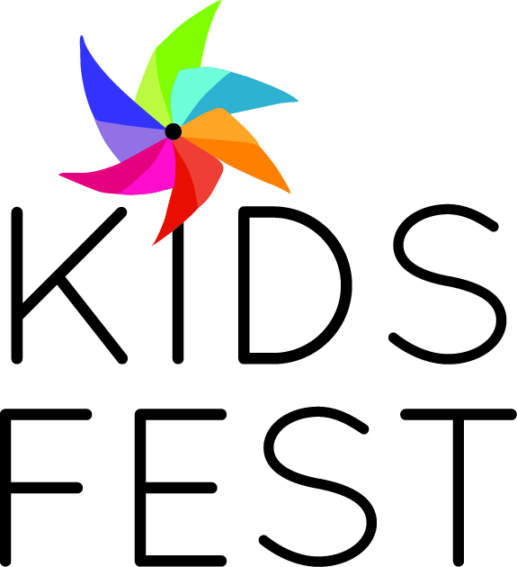

Businesses
Participate in Kid's Fest June 17th, 2017
Kid's Fest is a free family fun day on Saturday June 17th, 11-3 at McCoy Park in the Brookfield Village. Families enjoy a variety of kids activities, games, crafts, bounce house, a stage with live entertainment and food and drink. Businesses can set up a booth at Kid's Fest and have a game, kid's activity or give-a-way. It's a great way for businesses to get exposure in the community and promote their business. 600-800 in attendance.
$35
KID’S FEST 2017 BOOTH APPLICATION
June 17th, 2017
Business info & Payment Information
Company Name

Address:

City, State & Zip Code: | Phone
Contact Name: | email
Booth set up is the responsibility of the business.
Please make check out to Brookfield Village, LTD and return sponsorship form and payment to:
BVL, 2965 N. Brookfield Rd, Brookfield, WI 53045

