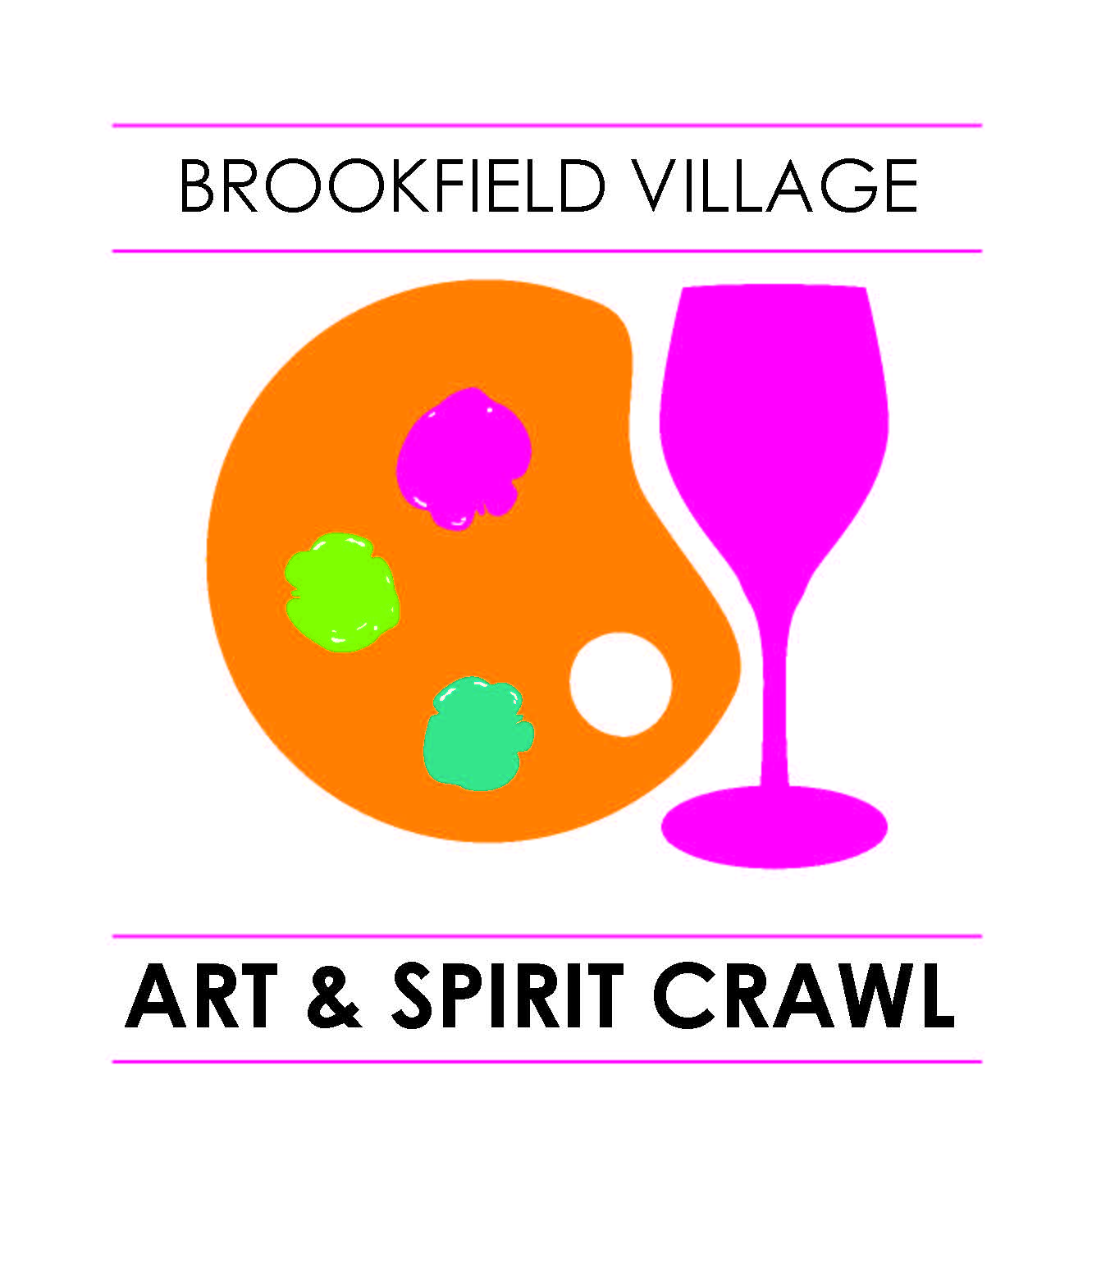
Brookfield Village Art and Spirit Crawl
Friday, October 21, 2016, 4pm– 9pm

Artist Application
Fee:$35
*Name:_______________________________________________________________
*Name as it is to appear in publicity & booth signs: ______________________________________________________________________
*Address: ______________________________________________________________ *City:_______________________________ *State:____________ *Zip:_____________
*Phone: ___________________________ * e-mail:______________________________
Web site:______________________________________________________________
*Category of my artwork:
Folk Art _____ Mixed Media _____ Stained Glass _____Water Color _____ Oil Painting _____ Acrylic _____ Jewelry _____ Large sculpture _____ Pottery _____ Wood Craft _____Photography ______ Other: _____________________
*Art description: ________________________________________________________________________________________________________________________________________________________________________________________________________________________________________________
Where have you exhibited before: ___________________________________________
Check if student art: ________ School ________________________________
Did you participate in the 2015 Art & Spirit Crawl: Yes _____ No _____

This is not a juried art show but to ensure the quality and consistency of art, and variety of mediums represented please submit 3 jpeg images of your art to dawnfarina@mac.com or include 3 pictures with this application.

Artists will be paired with a Village Business who will have space for 1 or more artists.
Would you be interested in displaying as an indoor exhibitor only? Yes____ No____
Would you be interested in displaying as an outdoors exhibitor? Yes____ No____
Locations will be assigned by the Art & Spirit Crawl Committee but if you have any special needs please let us know. While written requests will be considered, placement will be at the sole discretion of this committee.
Fee - $35. Make check payable to Brookfield Village Ltd. Fee can be submitted after notification of acceptance.
Please email application and images to dawnfarina@mac.com
Or send application and images to:
BVL Art Crawl/Olive Promotions, 2965 N. Brookfield Road, Brookfield, WI 53045

Questions can be directed to: Dawn Farina Condon 262-327-1020 or dawnfarina@mac.com

